

EC 1309- Measurement & Instrumentation

**Semi automatizing the physics lab experiment “calculating g using a pendulum”, using IR-based motion sensors**

A case study under guidance of

**Dr. Gaurav Singh Baghel Dr. Chandrajit Choudhury**

Submitted by

**Saransh Kumar 1714118**

**Prashant Jha 1714119**

**Pradeep Singh 1714120**

**Content**

1. Introduction
2. Project Requirements
3. Measuring Instruments
   1. Simple Pendulum
   2. IR Sensor
   3. Vernier Caliper
4. Arduino
5. Setup
6. Procedure
7. Code
8. Observation
9. Conclusion
10. **INTRODUCTION**

An Infrared motion sensor finds itself being used in various devices be it security cameras, lighting control, or a parking assistant, Infrared sensor is used in wide range of devices.

Despite the device being capable of fulfilling various purposes we will be focusing on a single aspect of the sensor for this case study which is semi automatizing the physics lab experiment “calculating g using a pendulum”.

When a pendulum will Swing in the Field of vision of IR sensor the time taken by the pendulum to start from a certain point and then reach that point again (Time Period) will be calculated more accurately by the IR Sensor as it is removing the possibility of human error, thus automizing the experiment and improving the accuracy.

**2. PROJECT REQUIREMENT**

* Simple Pendulum
* IR Sensor
* Arduino UNO
* Vernier Caliper
* Jump Wire

**3. Measuring Instruments**

**I. SIMPLE PENDULUM**

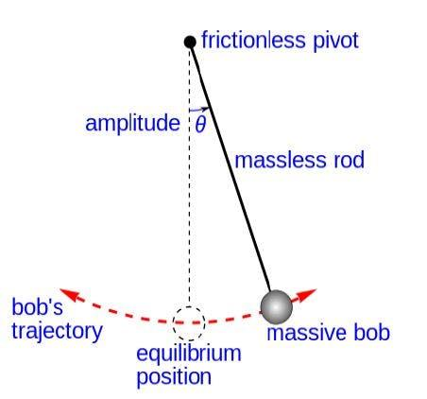

Figure :-Simple Pendulum

A pendulum is a weight suspended from

a pivot so that it can swing freely. When a

pendulum is displaced sideways from its

resting or equilibrium position, it is

subjected to a restoring force due to

gravity that tries to accelerate it back towards the equilibrium position.

When released, the restoring force acting on the pendulum's mass causes it to oscillate about the equilibrium position, thus causing it to swing back and forth. The time taken to complete one cycle, a left swing and a right swing, is called the time period of oscillation. The time period depends on the length of the pendulum and also to a slight degree on the amplitude, the width of the pendulum's swing.

The simple gravity pendulum is an idealized mathematical model of a pendulum. This is a weight (or bob) suspended at the end of a massless cord from a pivot, neglecting all retarding frictional forces. When given an initial push, the pendulum will swing back and forth at a constant amplitude. Real pendulums are subject to friction and air drag, so the amplitude of their swings gradually decays.

The time period of oscillation of a simple gravity pendulum depends on its length, the local strength of gravity, and to a small extent on the maximum angle that the pendulum swings away from the vertical, $θ_{0}$, called the amplitude. It should be noted that the period is independent of the mass of the bob. If the amplitude is limited to small swings, the period T of a simple pendulum, the time taken for a complete cycle is

𝑇 = 2π√𝐿/𝑔 --- (1)

under the condition $θ_{0}$ << 1 radian

where L is the length of the pendulum and g is the local acceleration due to gravity.

For small swings the period of swing is approximately the same for different size swings: that is, the period is independent of amplitude. This property, called isochronism, is the reason pendulums are so useful for timekeeping. Successive swings of the pendulum, even if changing in amplitude, take the same amount of time.

For larger amplitudes, the period increases gradually with amplitude so it is longer than given by equation (1). For example, at an amplitude of $θ_{0}$ = 23° it is 1% larger than given by (1). The period increases asymptotically (to infinity) as θ approaches 180°, because the value $θ_{0}$ = 180° is an unstable equilibrium point for the pendulum. The true period of an ideal simple gravity pendulum can be written in several different forms, one example being the infinite series:

𝑇=2π√𝐿/𝑔 [1+1/16 $θ_{0}$ ^2 + 113072 $θ_{0}$ ^4 +…)

Where $θ_{0}$ is in radians.

From equation (1) the local value of acceleration due to gravity can be calculated as

g = (4π²𝐿)/T²

Damping is an influence within or upon an oscillatory system that has the effect of reducing, restricting or preventing its oscillations. In most physical systems, damping is produced by processes that dissipate the energy stored in the oscillation. Due to damping the amplitude of oscillation goes on decreasing and finally reaches mean.

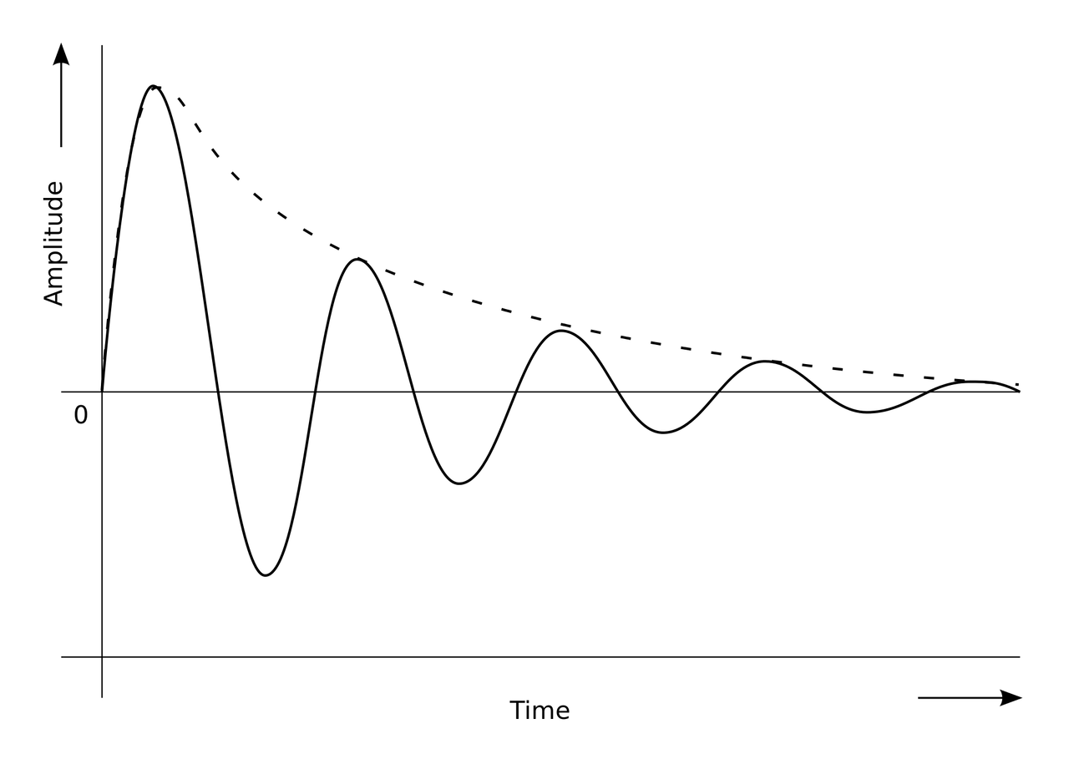

Figure :- Amplitude VS time graph of a pendulum

**II. IR SENSOR**

An infrared (IR) sensor is an electronic device that measures and detects infrared radiation in its surrounding environment. Infrared radiation was accidentally discovered by an astronomer named William Herchel in 1800. While measuring the temperature of each color of light (separated by a prism), he noticed that the temperature just beyond the red light was highest. IR is invisible to the human eye, as its wavelength is longer than that of visible light (though it is still on the same electromagnetic spectrum). Anything that emits heat (everything that has a temperature above around five degrees Kelvin) gives off infrared radiation. There are two types of infrared sensors: active and passive. Active infrared sensors both emit and detect infrared radiation. Active IR sensors have two parts: a light emitting diode (LED) and a receiver. When an object comes close to the sensor, the infrared light from the LED reflects off of the object and is detected by the receiver. Active IR sensors act as proximity sensors, and they are commonly used in obstacle detection systems (such as in robots).

Passive infrared (PIR) sensors only detect infrared radiation and do not emit it from an LED. Passive infrared sensors are comprised of:

* Two strips of pyroelectric material (a pyroelectric sensor)
* An infrared filter (that blocks out all other wavelengths of light)
* A fresnel lens (which collects light from many angles into a single point)
* A housing unit (to protect the sensor from other environmental variables, such as humidity)

PIR sensors are most commonly used in motion-based detection, such as in-home security systems. When a moving object that generates infrared radiation enters the sensing range of the detector, the difference in IR levels between the two pyroelectric elements is measured. The sensor then sends an electronic signal to an embedded computer, which in turn triggers an alarm.

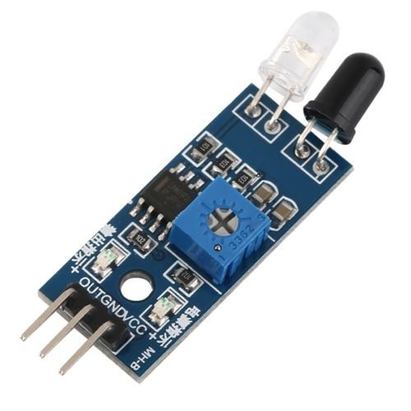

Figure :- IR Proximity Sensor

The principle of an IR sensor working as an Object Detection Sensor can be explained using the following figure. An IR sensor consists of an IR LED and an IR Photodiode; together they are called as Photo – Coupler or Opto – Coupler.

When the IR transmitter emits radiation, it reaches the object and some of the radiation reflects back to the IR receiver. Based on the intensity of the reception by the IR receiver, the output of the sensor is defined.

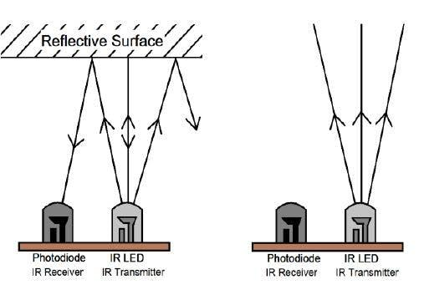

Figure :- Working of an active IR Sensor

**III. Vernier Caliper**

Vernier caliper, instrument for making very accurate linear measurements introduced in 1631 by Pierre Vernier of France. It utilizes two graduated scales: a main scale similar to that on a ruler and an especially graduated auxiliary scale, the vernier, that slides parallel to the main scale and enables readings to be made to a fraction of a division on the main scale. Vernier calipers are widely used in scientific laboratories and in manufacturing for quality control measurements.

In the figure, the vernier scale has 25 divisions, whereas the main scale has 24 divisions in the same length. This means that the divisions on the vernier scale are shorter than those on the main scale by 1/25 of a division on the main scale. In the figure, line 8 on the vernier coincides with line x on the main scale. To align lines 7 and y the vernier would have to be moved to the left by 1/25 of a main-scale division; to align lines 6 and 40, the movement would be 2/25, and so on. By similar reasoning, the 0 line on the vernier would have to be moved a distance equal to 8/25 of a main-scale division to align it with the 8.50 line on the main scale. This means that in the position shown in the figure the 0 line is 8/25 of a main-scale division to the right of the 8.50 line. The reading of the vernier is therefore 30 + 8.50 + 0.08 = 38.58.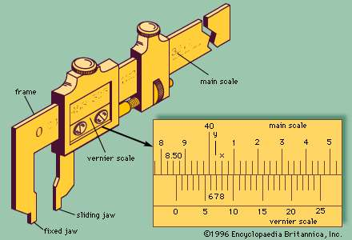

Figure :- A vernier calliper

**4. ARDUINO UNO**

The Arduino UNO is an open-source microcontroller board based on the Microchip ATmega328P microcontroller and developed by Arduino. The board is equipped with sets of digital and analog input /output (I/O) pins that may be interfaced to various expansion boards (shields) and other circuits.

The board has 14 Digital pins, 6 Analog pins, and programmable with the Arduino IDE (Integrated Development Environment) via a type B USB cable. It can be powered by a USB cable or by an external 9 volt battery, though it accepts voltages between 7 and 20 volts. The ATmega328 on the Arduino Uno comes preprogrammed with a boot loader that allows uploading new code to it without the use of an external hardware programmer. It communicates using the original STK500 protocol.

Arduino Uno uses C/C++ compiler to compile the uploaded code and performs its function. In this project we use Arduino to measure the time period of an oscillation and thus calculates the local value of acceleration due to gravity.

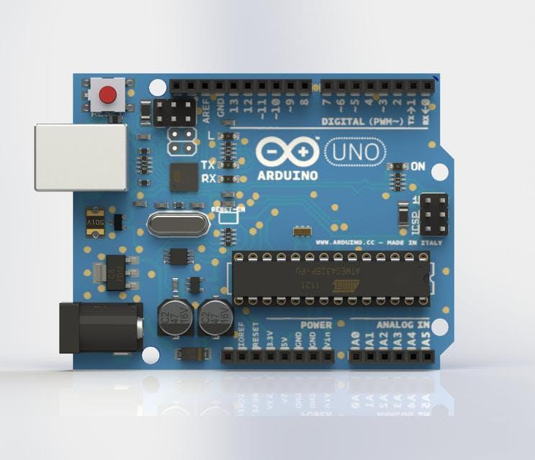

Figure :- Arduino Uno board

**5. SETUP**

The whole experiment setup consists of a simple pendulum, a virtual clock using IR proximity sensor and microcontroller. The schematic diagram of experimental setup is shown.

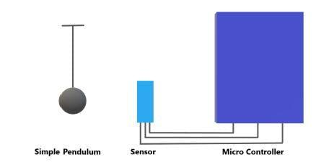

Figure :- Schematic Diagram

The proximity sensor can be connected to Arduino Uno as

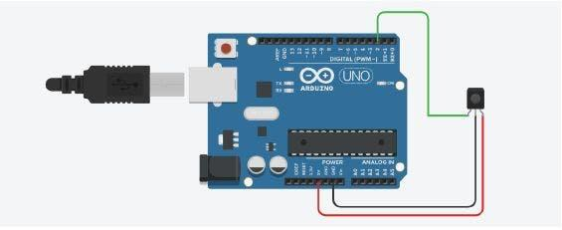

Figure :- Pin connection of IR sensor

**6. PROCEDURE**

**I. SIMPLE PENDULUM**

A simple pendulum of suitable length (~15 cm calculated using Vernier caliper to reduce errors) is made using a bob and a massless inextensible string.

**II. SENSOR**

Place the IR sensor at the suitable distance below or beside the bob of simple pendulum so as to get the maximum accuracy in measurement. The accuracy is verified for various baud rates of microcontroller.

And this is how the sensor works, in an oscillation whenever the bob covers the IR sensor it will return a value 0 to the microcontroller otherwise it will return 1 to the microcontroller.

**III. ARDUINO UNO**

Arduino Uno is the brain of this project, it reads the value from the IR proximity sensor and the measure the time between two consecutive 0 values, is the half of time period. For each half oscillation it calculates the value of ‘g’ and by adding the consecutive ‘g’ values of two half oscillations the mean value of ‘g’ for one oscillation is found. As the oscillations proceed the amplitude of oscillations goes on decreasing. By the data collected using IR sensor a real time damping curve is drawn.

**IV. REPEATATION**

This Process is repeated with different length of the string to reduce the errors and get more precise value.

**7. CODE**

The code which is to be Uploaded into the Arduino via the Serial Port is

unsigned long pretime;

unsigned long currtime;

int pin = 2;

float timePeriod;

boolean flag = true;

float g, g1=0, t;

int i = 0;

float l = 0.0000; // Enter the length of pendulum String

void setup(){

Serial.begin(9600);

pinMode(pin, INPUT);

pretime = micros();

Serial.println("calibrating");

}

void loop(){

if (digitalRead(pin) == 0)

{

if (flag == true)

{

currtime = micros();

timePeriod = currtime-pretime;

pretime = currtime;

flag = !flag;

t=timePeriod/1000000;

g=(39.48*l/(t*t)); // (4π²= 39.48)

g1=(g1+g)/2.0;

if (i%2==0){

if (g<12 && g>7){

Serial.println(g);

g1,g=0;

}

}

i+=1;

}

else{

flag = !flag;

delay(100);

}

}

for (i=0;i<360;i++)

{ Serial.println(10*t*sin(DEG_TO_RAD*i)); } // for real time damping curve

}

**8. OBSERVATION**

For small amplitude oscillations the local value of acceleration due to gravity is printed in the serial monitor.

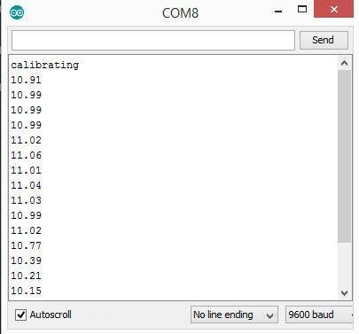

Figure :- Serial Port Output

Also a real time damping curve is observed in the serial plotter

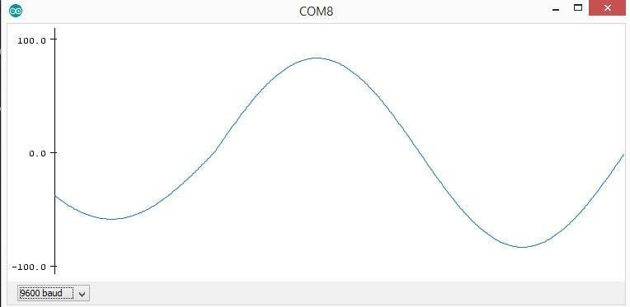

Figure :- Damping Curve

**9. CONCLUSION**

Calculating on paper is never an easy job. When it comes to complex formulas it is nothing but a short nightmare. So it is better to replace the scary calculations with a small computer program. The better part is that the observations and values are more accurate when using sensors. In this project we have automated the tedious calculations with a small computer program. In this technical era it seems to be worth.